

**ADDING A LAYER OF TRUST AND TRANSPARENCY UPON EXISTING VOTING SYSTEMS USING**

**BLOCKCHAIN TECHNOLOGIES**

BY

EMMANUEL OCHE SAMUEL

STEPHANIE OLOKO

JEREMIAH BENJAMIN OSIGBEMEH

FRANCIS OFOMATA

JOY ENWELIKU

BRITISH COLUMBIA,

NIGERIA

A CAPSTONE PROJECT

SUBMITTED TO THE FACULTY OF BLOCKCHAIN STUDIES AND ARTIFICIAL INTELLIGENCE

AT THE ALTHASH UNIVERSITY

IN PARTIAL FULFILLMENT OF THE REQUIREMENTS FOR

THE COLLEGIATE OF SCIENCE IN BLOCKCHAIN STUDIES

CHICAGO, ILLINOIS

©2023 EMMANUEL OCHE SAMUEL

**ABSTRACT**

This study examines how blockchain technology can increase voting systems' transparency and trustworthiness. Traditional voting systems have weak security, little transparency, and trouble ensuring the accuracy of results. By utilizing the characteristics of blockchain, such as immutability, decentralization, and transparency, the study seeks to address these problems.

The findings highlight various advantages of using blockchain into voting systems. To begin, blockchain ensures the immutability and transparency of votes, limiting unauthorized changes and increasing trust in the voting process. Second, decentralization reduces reliance on a central authority, lowering the danger of manipulation and increasing system resilience. Finally, cryptographic techniques allow for safe voter identification and anonymous voting, assuring privacy while retaining integrity.

Finally, the analysis demonstrates that blockchain technology has the potential to significantly improve confidence and transparency in voting systems. The suggested method solves the constraints of existing voting systems by exploiting blockchain's unique qualities such as decentralization, immutability, and cryptographic security. Implementing a blockchain-based voting system can improve the process's integrity, boost public trust, and create a more resilient method for democratic decision-making.

However, further study and field testing are needed to address scalability, usability, and regulatory issues before widespread adoption can occur. The findings add to the current body of information on using blockchain to improve confidence and transparency in voting systems. This study emphasizes the necessity of pursuing novel solutions to better the democratic process and establishes the groundwork for future advances in blockchain-based voting technologies.

*Keywords: Blockchain technology, Transparency, Trustworthiness, Immutability, Decentralization, Cryptographic techniques, Voting systems*

**Insights**

In the era of 21st-century technological breakthroughs, blockchain technology has revolutionized numerous sectors by introducing decentralization, transparency, and trust through consensus mechanisms. Building upon this transformative power, our group capstone project aims to add a layer of trust and transparency to existing systems using blockchain technologies.

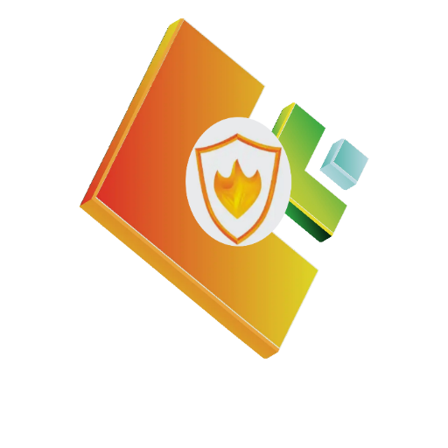



**VOTER TRUST TOKEN (VTT)**

*Introducing the 'Voter Trust Token' (VTT). Our project leverages the Althash blockchain to create a token that empowers voters to participate in elections with confidence. By utilizing the decentralized nature of blockchain, VTT ensures that every vote is securely recorded, eliminating concerns of manipulation and bolstering trust in the election process.*

*This innovative undertaking proposes a total supply of 7.4 billion tokens, symbolizing the entire global population, thereby highlighting the inclusive nature and broad applicability of our solution.*

**PROJECT PROBLEM STATEMENT**

The Bone of Consensus is the lack of confidentiality and trust in the electoral process. These electoral processes are carried out by electoral teams, organizations and administrations, which are more or less centralized. The centralized nature of these organizations and administrations make them subject to:

1. Monopolization and monopolistic Operations
2. Electoral Fraud and Rigging
3. Voter Suppression
4. Fraudulent Voting
5. Vote Buying, and many other problems and issues

**Practical Scenario(s)**

**USA**

DONALD TRUMP’S ELECTION PERIOD IN AMERICA: several instances of electoral malpractices were reported, raising concerns about the integrity of the democratic process.

One notable example was the controversy surrounding foreign interference and hacking attempts aimed at influencing the election outcome.

**RUSSIA**

The Russian interference in the 2016 U.S. presidential election, as revealed by multiple intelligence agencies, highlighted the vulnerability of electoral systems to external manipulation

**NIGERIA**

In Nigeria, the just concluded 2023 Presidential Elections and also in former times.

**BRAZIL**

One example of electoral malpractice in Brazil occurred in the year 2018 during the presidential elections. It involved the dissemination of false information through social media platforms, particularly WhatsApp. Misleading messages were spread, targeting specific candidates with the intention of manipulating public opinion and influencing voter decisions. This malpractice undermined the integrity of the electoral process by distorting the information available to voters and potentially swaying the outcome of the election.

**NECESSITY OF A NEW METHOD**

Giving the above problems listed, there is a necessity of a new method of:

* Voting
* A Decentralized Procedure
* No central authourity needed
* Transparency
* Security
* Immutability
* Popular Ownership
* Monitored Electoral Process
* A Decentralized Voting System

A Decentralized form of voting will answer more readily, the demands of Democracy.

This is the problem VTT has come to solve.

**SOLUTION TO THE PROBLEM:**

The implementation of a blockchain-based decentralized voting system using the Voters' Trust Token (VTT) addresses the lack of confidentiality and trust in the electoral process, while mitigating various electoral malpractices. Here's how the VTT can solve the listed problems.

* Monopolization and Monopolistic Operations:

By decentralizing the voting process, VTT ensures that no single entity can monopolize or manipulate the system. All transactions and records are transparent and immutable, preventing any undue influence on the electoral process.

* Electoral Malpractices:

VTT's decentralized nature ensures that voting procedures are transparent and accessible to all stakeholders and voters, minimizing the chances of electoral malpractices. Smart contracts can be utilized to enforce predefined rules, preventing any unauthorized activities during the voting process.

* Vote Buying:

VTT's unique token distribution to registered voters makes it difficult to buy votes or engage in any vote-buying schemes. The transparency of the blockchain enables stakeholders to monitor and verify the integrity of the voting process, discouraging any attempts to manipulate the outcome through financial incentives.

**PROJECT VISION, MISSION, GOALS AND OBJECTIVES**

**i. Vision:**

To establish a secure, transparent, and inclusive electoral process that fosters trust, confidentiality, and equal participation through the implementation of a blockchain-based decentralized voting system using the Voters' Trust Token (VTT).

**ii. Mission:**

Our mission is to leverage blockchain technology to revolutionize the electoral process, ensuring the integrity and fairness of elections while promoting democratic principles and eliminating electoral malpractices.

**iii. Goals:**

Develop a robust and scalable decentralized voting system that leverages the benefits of blockchain technology. Foster trust, transparency, and confidentiality in the electoral process, addressing the existing issues in centralized voting systems. Empower voters by providing a secure and accessible platform to exercise their voting rights without fear of malpractices or suppression.

Mitigate electoral fraud, violence, vote buying, and other malpractices, ensuring fair and credible elections.

**TOKEN MAXIMUM SUPPLY:**

For the maximum token supply, consider a value of 7.4 billion tokens. This quantity allows for a larger supply while still maintaining scarcity and value. It provides flexibility for token distribution and potential future use cases.

**TOKEN BUDGET ALLOCATION:**

The budget allocation for the project is divided as follows:

Development and Smart Contract Audit: 30%

Marketing and Promotion: 25%

Operations and Administration: 15%

Research and Innovation: 15%

Legal and Compliance: 10%

Reserve Fund: 5%

The Reserve Fund can be used for future development, partnerships, or unforeseen expenses.

**TOKEN SLOGAN:**

The slogan for Voter Trust Token (VTT) is: "Empowering Democracy with Blockchain Trust."

**LAUNCH DATE:**

The proposed launch date for the VTT token is set as October 1st, 2023. This date 1st of October (Independence Day) in Nigeria aligns with the significance of Democracy & elections in Nigeria. Launching on this day provides a target for development and marketing timelines.

**TOKEN LOGO:**

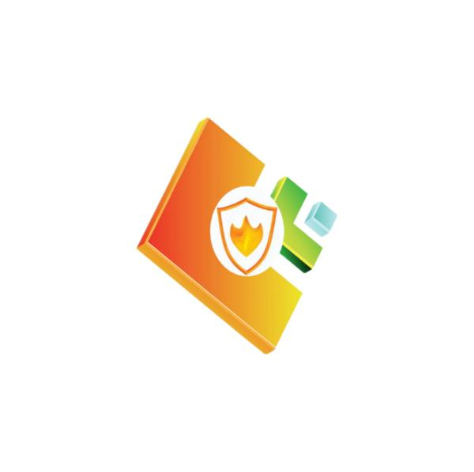

**TOKEN NAME**

Voters Trust Token (VTT), originates from three fundamental components. Firstly, "Voters" signifies the individuals who are at the core, serving as the primary stakeholders and beneficiaries of the token. Secondly, "Trust" underlines its purpose of revitalizing and strengthening trust within the electoral process. Lastly, "Token" emphasizes its digital nature, constructed on the foundation of blockchain technology. Through the amalgamation of these elements, the VTT token aspires to enable voters, tackle the significant issue of trust in elections, and harness the transparency and security inherent in blockchain to enhance the integrity of the electoral system.

**TOKEN TICKER**

Token name: Voters Trust Token (VTT)

Purpose: Restore trust in elections

Key Elements:

Empower voters

Leverage blockchain technology

Address the issue of trust in the electoral process

Benefits:

Enhance transparency and security

Reinforce democratic values

Ensure fair representation

Token Name: Voters Trust Token (VTT)

Voters: Primary stakeholders

Trust: Solving trust issues

Token: Digital asset on blockchain

**CONCLUSION**

The lack of confidentiality and trust in the electoral process is hinged on its centralized nature.

A Decentralized form of voting will answer more readily, the demands of Democracy. This is the problem VTT has come to solve.

**BLOCKCHAIN OATH OF PROFESSION**

It is my duty as a Blockchain Professional to advance my neighborhood, the global economy, and the Blockchain sector.

As a Blockchain Professional, I will do all of my duties with the highest Honesty, Responsibility, Integrity and Intelligence.

I will provide mentorship to other Blockchain specialists without any type of bias to ensure that we all succeed in advancing the industry and the global community.

I will be mindful of what society and business require, and I'll apply my skills and knowledge to meet those needs.

I willingly accept this oath as a Blockchain professional, and I will adhere by its principles.

So help me God.